Harrison Community Schools
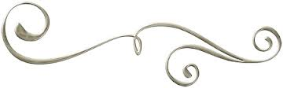
Band Handbook

Contact Information
Mrs. Seanne Danielak, Director Of Bands
Mrs. Danielak’s School E-Mail: SDanielak@HarrisonSchools.Com
Hornet Band E-Mail: HarrisonHornetBands@Gmail.Com
Website: www.HornetBands.Weebly.com
Phone: (989) 539-7194 (Ext. 1335)
Facebook: Hornet Bands

